 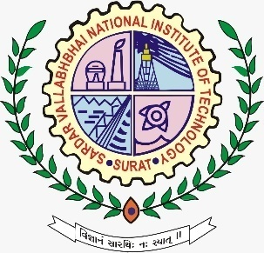

**Plan My Route**

**Objective:-**

Hey, I am keshav. I am a travel enthusiast. I am visiting Jodhpur on 20th Feb. Help me plan my travel route with limited amount of time and modes of transportation (Bus, Rikshaw and Car).

Distance between all places (location) will be provided.

Travel cost and time taken by modes of transportation will be provided

**Rules**:-

* All places must be visited in planned route.
* To return to given initial given place covering all the places.
* Must have 20% Car route out of total route.
* Maximum 50% route can be covered by rikshaw.
* Atleast visit one restaurant for lunch.
* 'A' restaurant provide lunch at 450/-
* 'B' restaurant provide lunch at 600/-
* 45 minutes required for lunch in any restaurant.

**Time Limit**:- 30 minutes.

**Judging Criteria**:-

Total travel cost = A

Total time taken

to return to initial place = B

Final Score= 2×A + 7×B

Team with Minimum Score will be winner.

**Co-ordinators:-**

Keshav Patel (9571503467)

Amit Patel (79909 54284)

Umang Jain (94998 42005)

Param Joshi (91730 13333)

Om Patel (99786 87332)